SP_RESET_PRICE

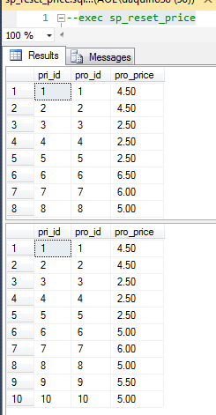

SP_UPDATE_PRICE_FROM_SALES

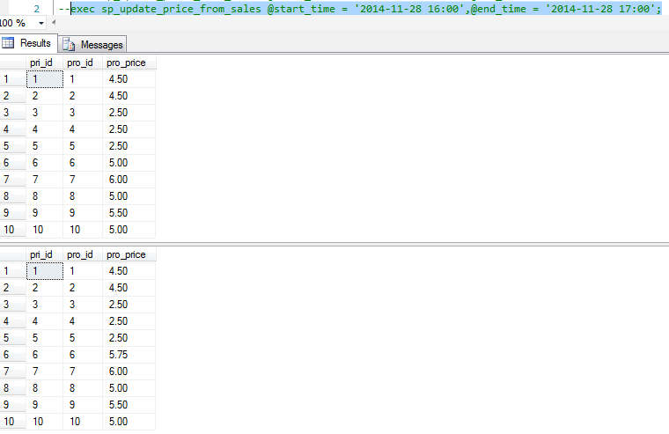

SP_ADD_POS_SALE

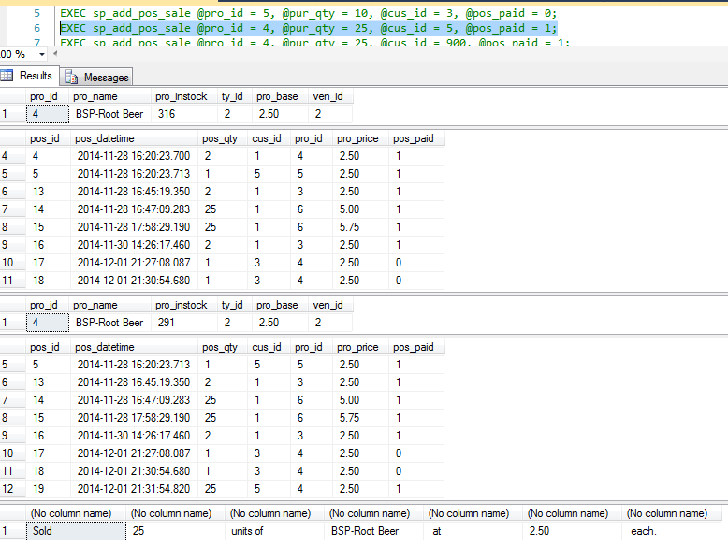

SP_UPDATE_ACCT_SALES

